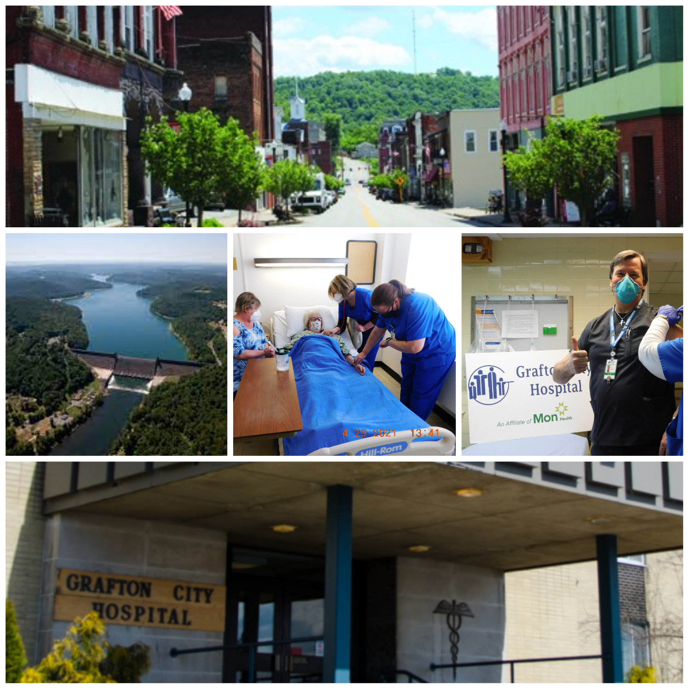
Our Commitment to Community Health
Grafton City Hospital (GCH) is a governmental not-for-profit organization that was created and is owned by the City of Grafton, West Virginia. First opening its doors to the public over 100 years ago, GCH is a Critical Access Hospital in Taylor County. In September 2019, GCH became an affiliate of Mon Health System. This affiliation helps ensure that Grafton and Taylor County citizens continue to have an independent health care choice close to home.

Grafton City Hospital is committed to providing patient friendly, quality health care to its communities. The hospital provides a continuum of care that includes acute and ancillary services. These services span a rural health clinic, cardio-pulmonary therapy, diagnostic imaging, laboratory services, physical therapy, 24/7 emergency room, and rehabilitation and fitness center. Grafton City Hospital is essential to the community and continues to explore ways to be effective and efficient in providing necessary healthcare services.

Grafton City Hospital Mission:
Our goal is to provide excellent care and hospitality
to the residents and guests of Taylor County and the surrounding communities.

Every three years, GCH conducts a Community Health Needs Assessment (CHNA) and develops a corresponding three-year Community Health Improvement Plan (CHIP) to better understand and respond to the health and wellness concerns for our community. The 2022 CHNA and 2022-25 CHIP build upon previous assessments and will continue to guide our community benefit and community health improvement efforts. Consistent with previous assessments, the 2022 CHNA and 2022-25 CHIP focus on the health needs of all residents of Taylor County.

We invite our community partners to learn more about the CHNA and CHIP and opportunities for collaboration to address identified health needs. Please visit our website: www.GraftonHospital.com or contact Community Outreach at 304-265-0400.

2022-25 Community Health Improvement Plan
What is a Community Health Improvement Plan (CHIP)?
A CHIP helps organizations move from data to action to address priority health needs identified in the CHNA. The CHIP serves as a guide for strategic planning and a tool by which to measure impact by detailing goals, objectives, strategies, and action steps over the three-year reporting timeframe. Anchoring initiatives and community benefit activities to measurable objectives, the CHIP creates a framework for measuring the impact of collective action towards community health.

Community Input
Like the CHNA, the CHIP reflects input from diverse stakeholders and helps to foster collaboration among community-based organizations. Community health priorities for GCH were identified in collaboration with Taylor County community agency representatives. These individuals provided input to define and recommend solutions to the historical and day-to-day challenges in our community. Together this input provided diverse perspectives on health trends, helped us better understand lived experiences among historically disenfranchised and underserved populations, and provided insights into service delivery gaps that contribute to health disparities and inequities.

Determining Community Health Priorities
To work toward health equity, it is imperative to prioritize resources and activities toward the most pressing and cross-cutting health needs within the community. To determine which priority needs GCH is best positioned to address during this planning cycle, the GCH leadership team considered CHNA research findings in conjunction with community recommendations, partners’ input and activities, and GCH’s strategic initiatives. The hospital will focus community benefit initiatives on the following priority areas during the 2022-25 planning cycle.

- Chronic disease prevention
- Mental health
- Substance use disorder

Developing a Plan for Health Improvement
Community health improvement requires collaboration among community-based organizations, policy makers, funders, and many other partners. A CHIP is a guide to move from data to action, to coordinate community resources, and to measure progress as a community. The GCH CHIP outlines goals and specific strategies to address our community’s most pressing health needs. We will continue to monitor and share our progress toward these efforts during the 2022-25 reporting cycle.

A summary of the GCH 2022-25 CHIP for the identified community health priorities follows.

Chronic Disease Prevention
Goal: Ensure all residents have knowledge of, and equitable access to, the resources they need to maintain and improve their health.

Objectives and Strategies:
- Objective: Increase access to traditional and alternative places people can access healthcare.
  - Partner with emergency medical services to explore Community Paramedicine models and funding opportunities to expand primary and preventive services to underserved populations.
  - Provide financial counseling to assist people acquire health insurance coverage.
  - Continue to assess community need for specialty care services and opportunities to expand available clinics.
  - Host and participate in community health fairs, offering affordable preventive screenings.
  - Expand equitable access to telehealth visits by increasing technology know-how and use of telehealth among priority populations.

- Objective: Increase availability of and access to community-based health and social services.
  - Host regular meetings with area health and social providers to facilitate networking, resource sharing, and joint community health improvement planning.
  - Partner with area health and social service agencies to explore transportation models (e.g., senior center transportation services, Here and There Transit) and funding opportunities.
  - Provide diabetic and weight loss education, led by a Registered Dietician.
  - Support, promote, and participate in community health events and wellness programs, targeting nutrition, tobacco cessation, and physical activity.
  - Support early health education and programming for youth in partnership with afterschool programs and Taylor County Schools.
  - Offer the Tygart Valley Rehabilitation & Fitness Center, providing fitness and wellness classes and discounted membership rates.
  - Partner with Grafton High School, the business community, and universities to expand youth career and technical programs and internship opportunities in healthcare.

- Objective: Increase the proportion of older adults receiving needed social and community support.
  - Partner with senior center transportation services to help older adults access area medical and dental offices.
  - Partner with the senior center, library, churches, and other community-based organizations to promote and offer older adult health and social services.
  - Implement intentional opportunities for social interaction among older adults at health fairs and other community events.
  - Work to reengage older adults in community volunteer opportunities.

Mental Health
Goal: Strengthen and support community initiatives that promote mental wellness, recovery, and resilience.

Objectives and Strategies:
- Objective: Improve access to mental health services and supports.
  - Continue to explore partnership opportunities with Mon Health-affiliated hospitals and other area providers for psychiatric service referrals.
  - Offer psychiatric evaluation, counseling, and social services as part of the Grafton Recovery Center.
  - Offer a Crisis Stabilization Unit for individuals experiencing a mental health emergency.
  - Strengthen and support community organizations providing youth mental health supports, including mentorship, relationship-building, and social emotional learning opportunities.

- Objective: Increase awareness of mental health to reduce stigma and fear of seeking treatment.
  - Conduct universal screenings in healthcare settings to identify individuals with mental health concerns.
  - Support, promote, and participate in community mental health awareness efforts.
  - Partner with the senior center to provide older adult mental health education and resilience activities (e.g., mindfulness, physical activity, coping skills).

Substance Use Disorder
Goal: Strengthen and support community initiatives to prevent the initiation of substance use and promote recovery.

Objectives and Strategies:
- Objective: Improve access to treatment and services for substance use disorder.
  - Provide the Grafton Recovery Center, offering psychiatric evaluation and therapy, social services and case management, and connections to rehab, detox, and sober living.
  - Provide transportation for patients accessing Grafton Recovery Center services and experiencing transportation barriers.
  - Provide telehealth services for the Grafton Recovery Center as a convenient care option and to address access barriers.
  - Provide Medication-Assisted Treatment (MAT) for patients experiencing alcohol and/or opioid addiction.
  - Provide an adult inpatient short-stay program offering 24-hour support, supervision, and nursing care, with the goal of helping individuals through a period of acute and/or significant withdrawal symptoms from alcohol and/or opioids.
  - Continue to explore implementation of peer recovery and additional detox services.

- Objective: Increase awareness of substance use disorder to prevent initiation and reduce fear of seeking treatment.
  - Conduct universal screenings in healthcare settings to identify individuals with substance use disorder.
  - Support, promote, and participate in community substance use disorder awareness and training efforts.
  - Partner with Taylor County Schools and other community organizations to provide youth substance use disorder education.

Next Steps
Grafton City Hospital is committed to advancing initiatives and community collaboration to support the issues identified through the CHNA. The 2022 CHNA report was presented to the GCH Board of Directors and approved in June 2022. The corresponding three-year CHIP was presented to the GCH Board of Directors and approved in September 2022.

Grafton City Hospital welcomes your partnership to meet the health and medical needs of our community. We know we cannot do this work alone and that sustained, meaningful health improvement will require collaboration to bring the best that each of our community organizations has to offer. To learn more about GCH’s community health improvement work or to discuss partnership opportunities, please visit our website: www.GraftonHospital.com or contact Community Outreach at 304-265-0400.

